Team Number: 1

Team Name: Ski Free

Team Members:

Jack Savio (GitHub - js678, email- [jasa6380@colorado.edu](mailto:jasa6380@colorado.edu))

Luke Gosnell (GitHub - lugo7099 - Email - [lugo7099@colorado.edu](mailto:lugo7099@colorado.edu))

Xan Gardner (GitHub - gardnerxm email - [xaga9713@colorado.edu](mailto:xaga9713@colorado.edu))

Conrad Barron (GitHub - 1RadCon1 email - [conrad.barron@colorado.edu](mailto:conrad.barron@colorado.edu))

Andrew Lan(Github - AndrewL7, Email - [xila6676@colorado.edu](mailto:xila6676@colorado.edu))

Parker Allen (GitHub - ParkerrAllen email- [paal5881@colorado.edu](mailto:paal5881@colorado.edu))

Application Name: Karv

Application Description:

This application will be an all in one ski marketplace where the users can buy equipment, find ski resorts, find out how close ski resorts are to them, etc. There will be a registration page, login page, a profile page, a home page, a cart page, purchase page, a planning page for planning a ski trip, a search function for finding and buying equipment, logout function, a search function for finding ski resorts, and a connection to a google api so that the user can see how far the ski resort is from them.

Vision Statement: To be the world’s leading guide to discovering your new life within skiing.

Verson Control:<https://github.com/js678/SkiGroupProject2023>

Development Methodology; Agile

Communication Plan: Our group plans to communicate through the discord server.

<https://discord.gg/VSJ2NPuF>

Meeting Plan:

* TA Meeting Time: Wednesday 1:45 PM
* Group Meeting Time: 5:30 PM Thursday
* Modality: Week-to-week, depending on availability to in-person meetings

Use Case Diagram:

Wireframes:

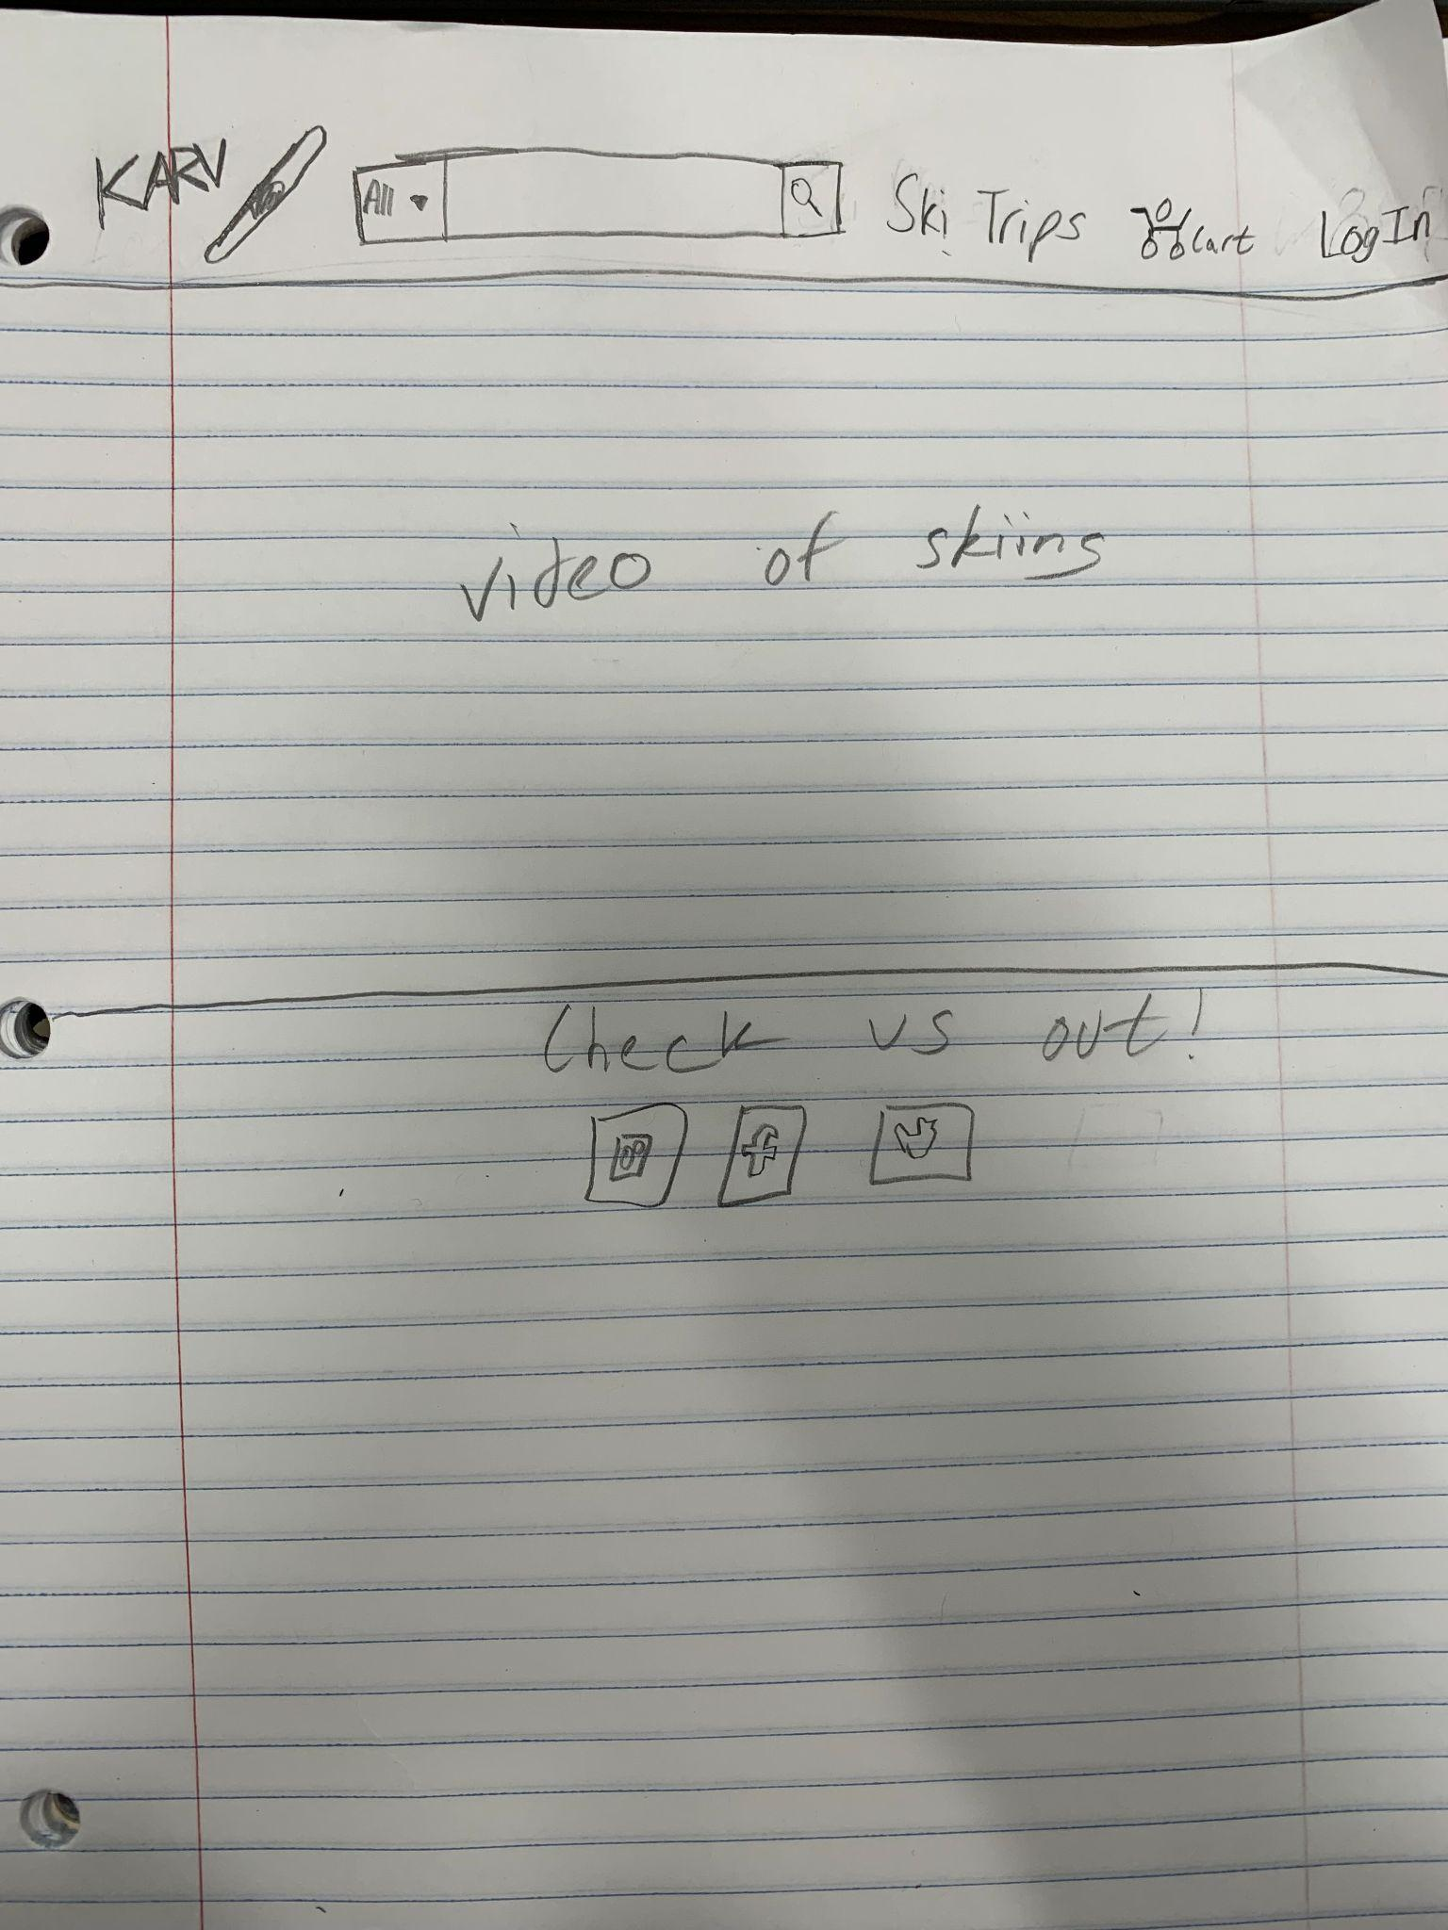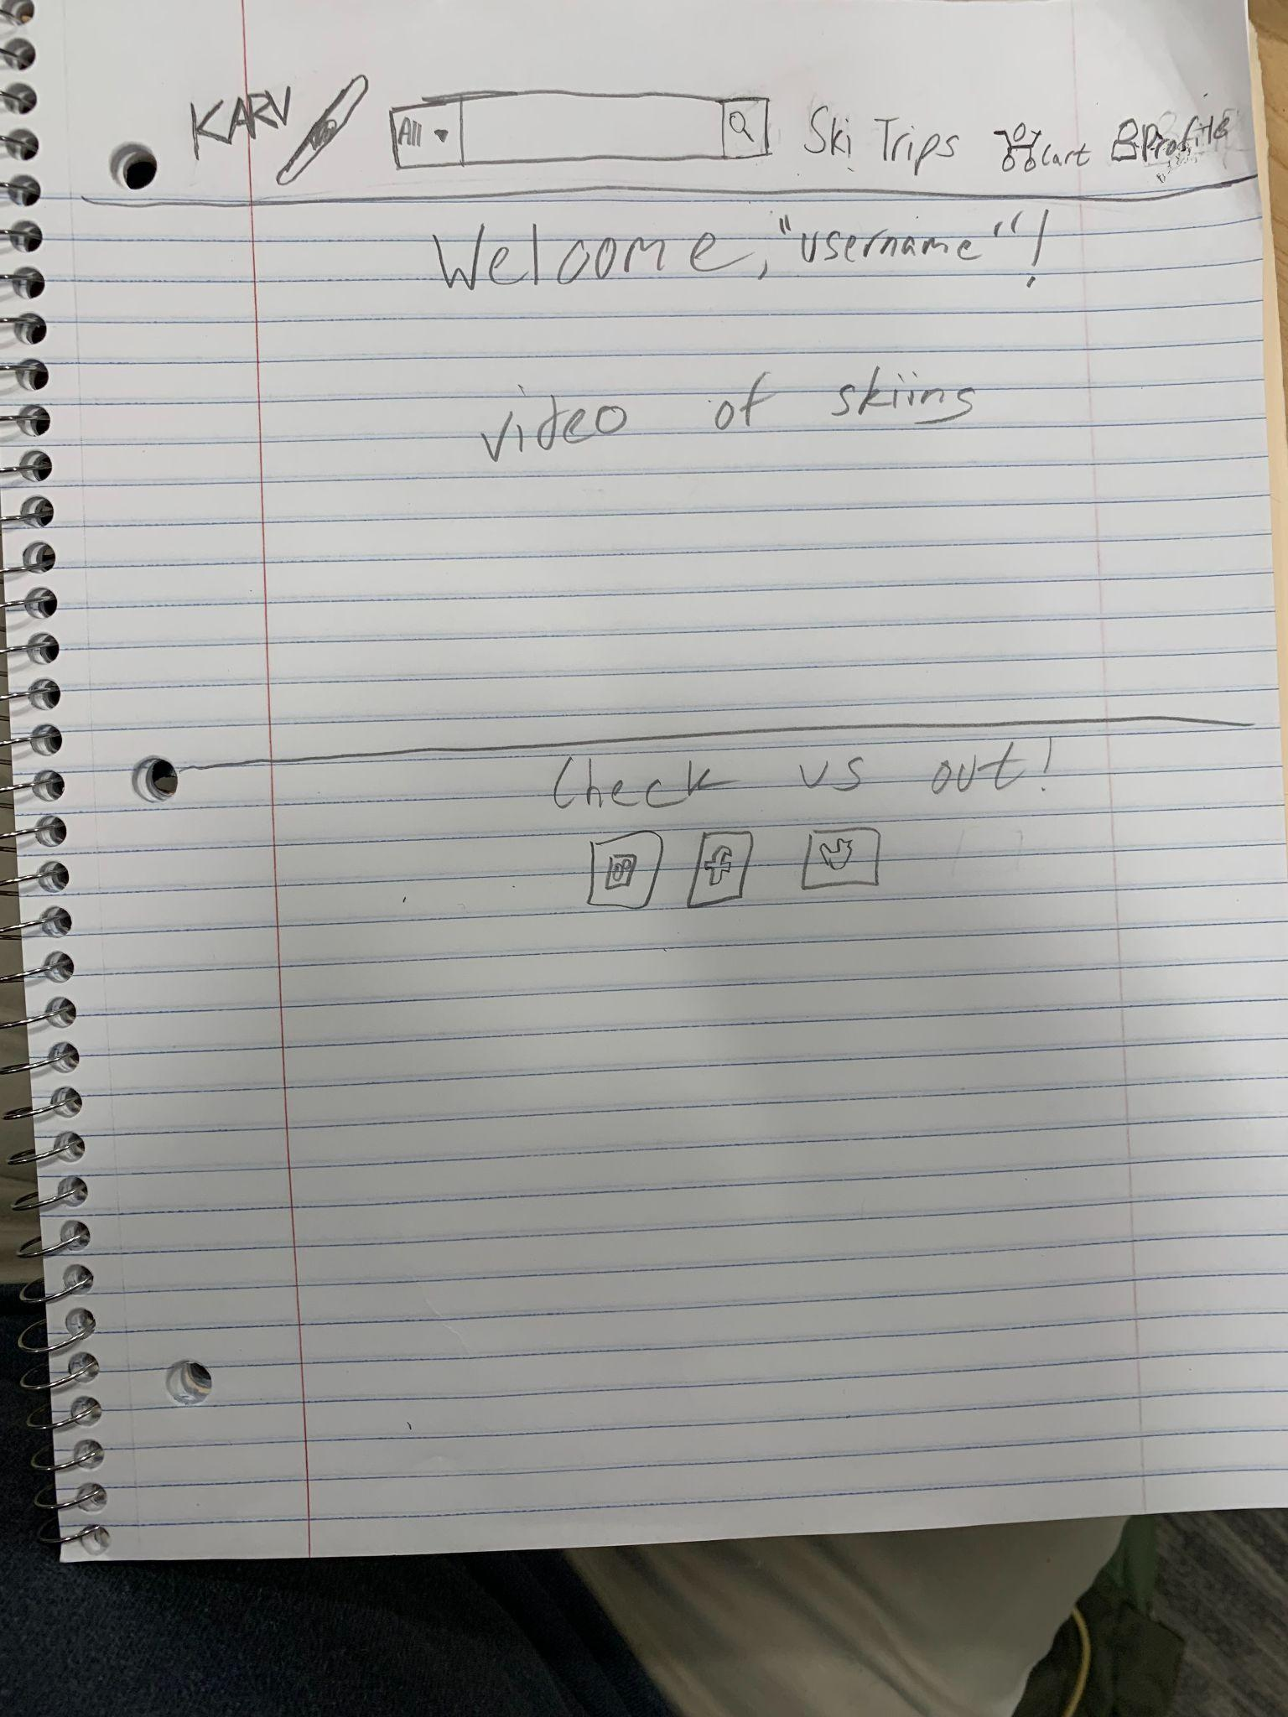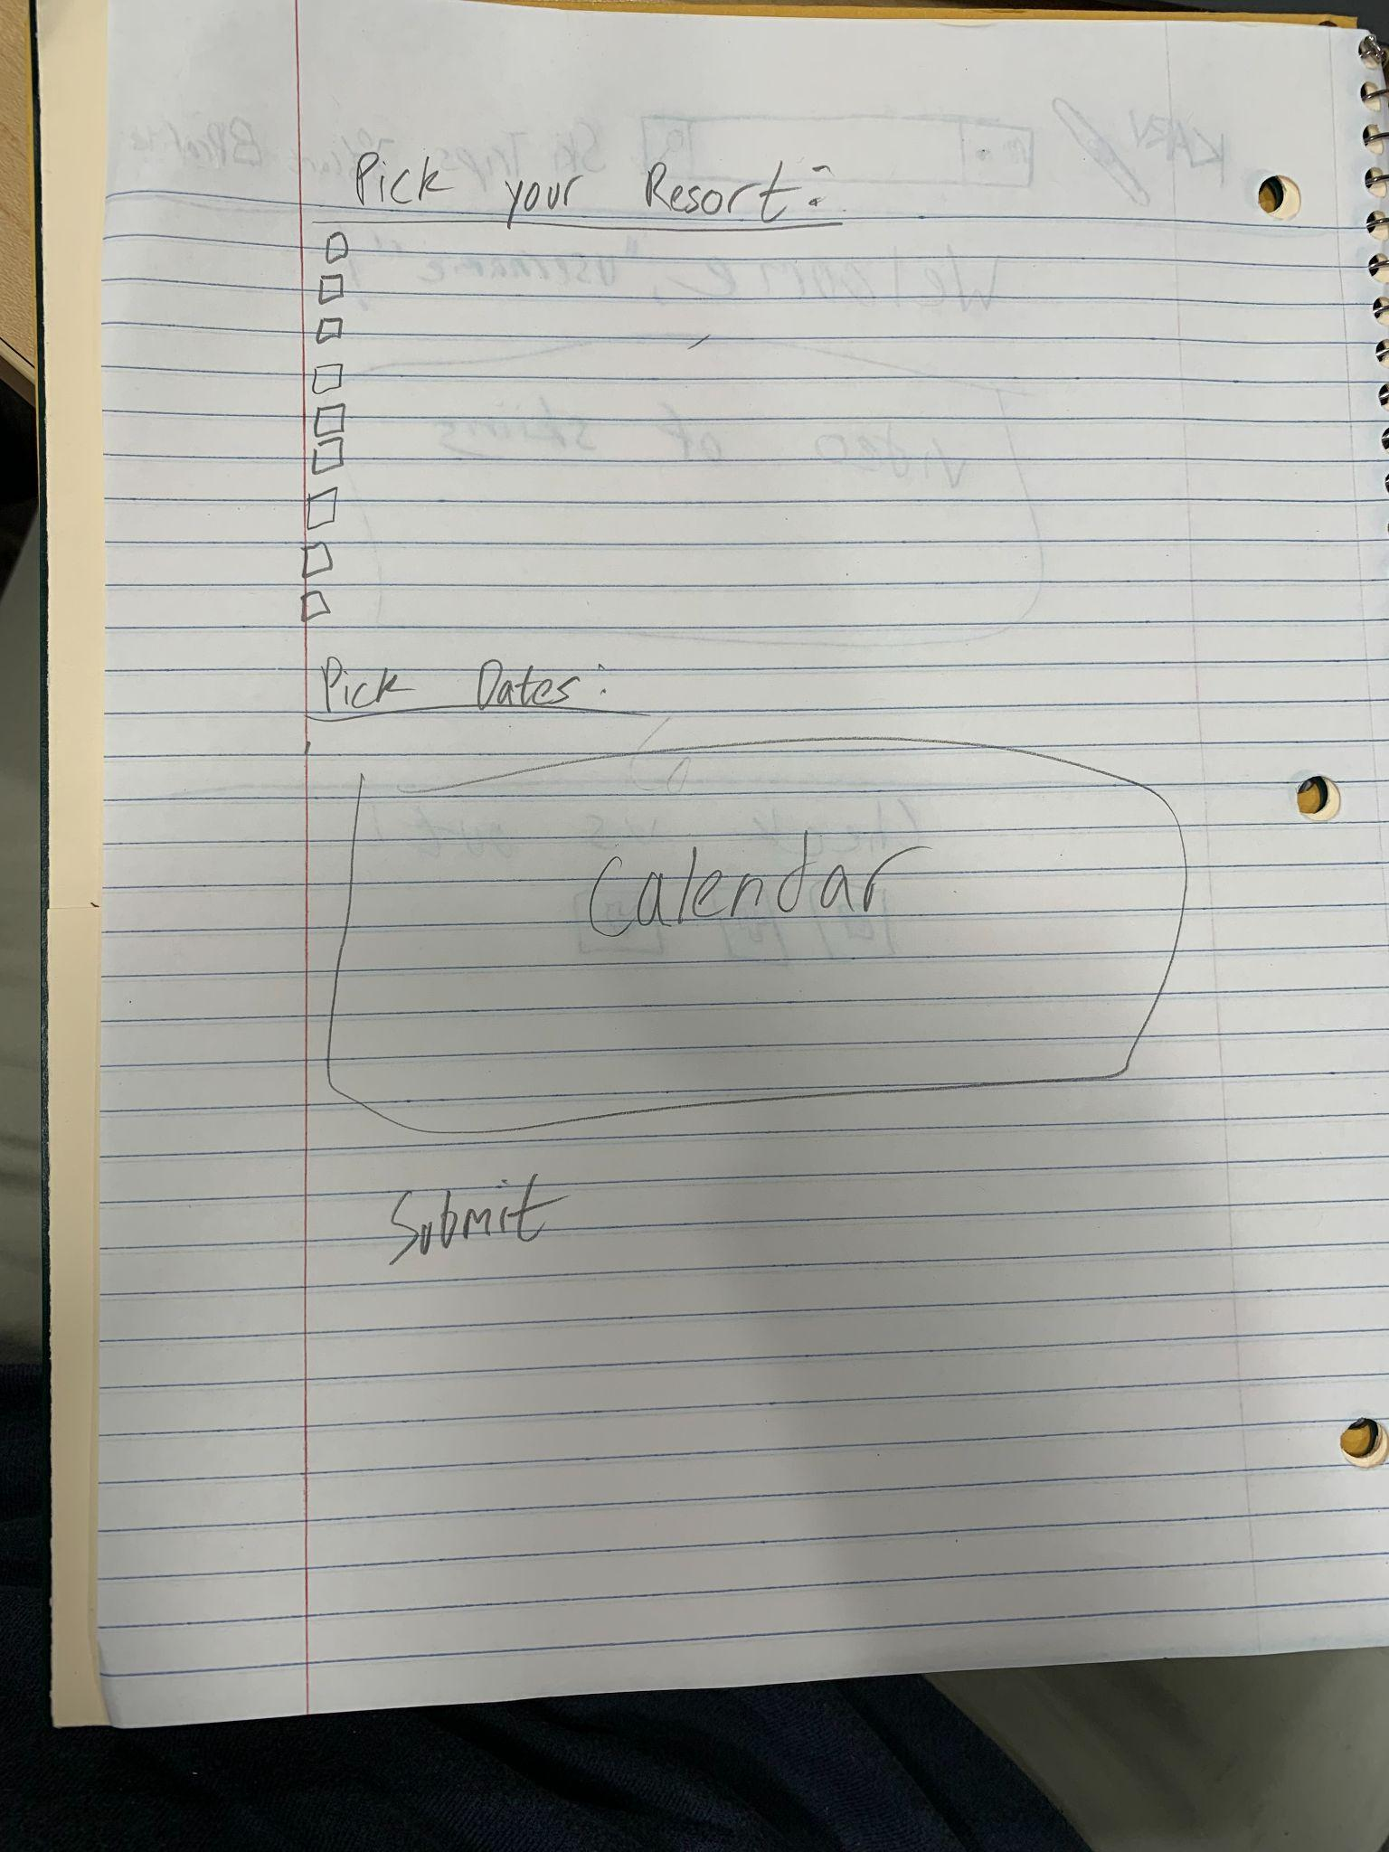

Notes:

Apis for ski equipment, ski resorts, google api for how far resorts are  
Planning a ski trip

If they want to pick up equipment from a location

Can copy info from an excel spreadsheet into a database

Possible APIs:

Ski API Technologies

evo.com